LAB-2
Question:
Aim:
To perform exploratory data analysis (EDA) on a student performance dataset using Pandas and Matplotlib.
Dataset:
Create a CSV file named student_data.csv with the following data:
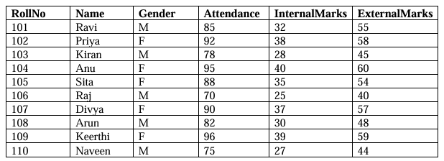
Tasks:
Task A: Dataset Loading and Inspection
. Import the necessary Python libraries.
. Load the dataset into a Pandas DataFrame.
. Display the first five records.
. Display the last five records.
. Find the total number of rows and columns.
. Display the names of all columns.
. Display the data type of each column.
· Generate dataset information using info().

Code:
import numpy as np
import pandas as pd
df=pd.read_csv('student_data.csv')
print("\n first five records:")
print(df.head())
print("\n last five records:")
print(df.tail())
print("\n total no.of rows and columns:",df.shape)
print("column names:",df.columns.tolist())
print("datatypes:",df.dtypes)
print(df.info())
Output: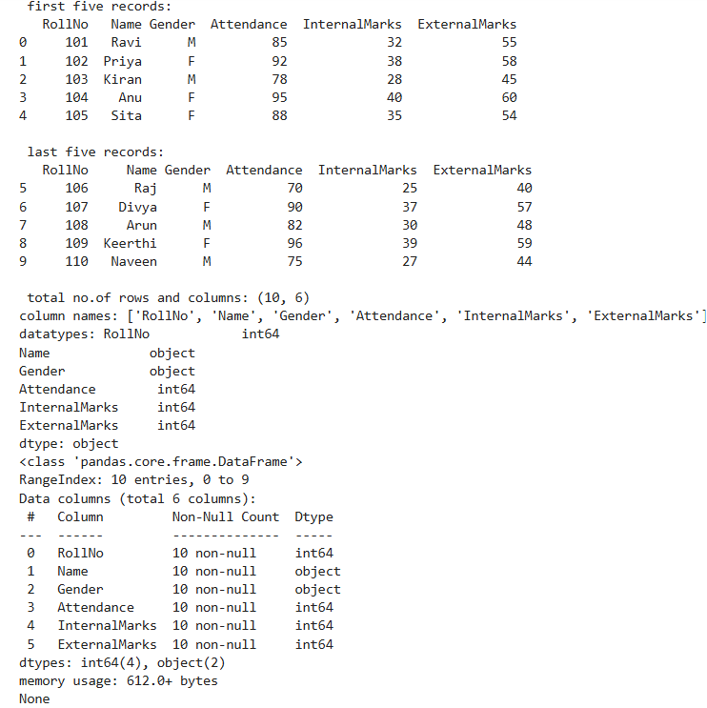

Task B: Statistical Analysis
. Calculate the mean attendance of all students.
. Calculate the average Internal Marks.
. Calculate the average External Marks.
. Find the maximum Internal Marks.
. Find the minimum Internal Marks.
. Find the maximum External Marks.
. Find the minimum External Marks.
. Calculate the standard deviation of Internal Marks.
. Generate summary statistics using describe().
Code:
import numpy as np
import pandas as pd
print("\n mean attendance of all students:",df["Attendance"].mean())
print("\n Avergae Internal marks:",df["InternalMarks"].mean())
print("\n Average External marks:",df["ExternalMarks"].mean())
print("\n Maximum Internal marks:",df["InternalMarks"].max())
print("\n Minimum Internal marks:",df["InternalMarks"].min())
print("\n Maximum External Marks:",df["ExternalMarks"].max())
print("\n Minimum External Marks:",df["ExternalMarks"].min())
print("\n Standard deviation of Inernal marks:",df["InternalMarks"].std())
print("\n Summary statstics:",df.describe())

Output:
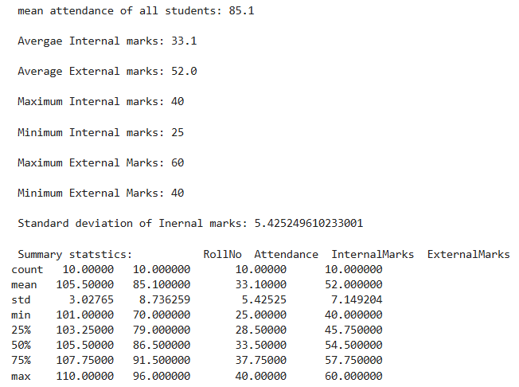

Task C: Data Manipulation
. Create a new column named TotalMarks.
. TotalMarks=InternalMarks+ExternalMarks
. Create a new column named Percentage.
1. Percentage=TotalMarks/100x100
. Display the updated DataFrame.
Code:
df["TotalMarks"]=df["InternalMarks"]+df["ExternalMarks"]
df["Percentage"]=(df["TotalMarks"]/100)*100
print(df.to_string())

Output:
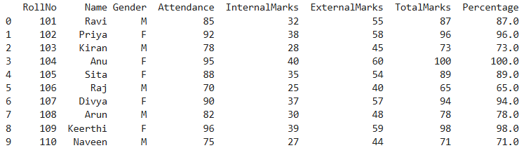

Task D: Filtering and Searching
. Display the details of students whose attendance is greater than 90%.
. Display the details of students whose TotalMarks exceed 90.
. Display the details of female students.
. Display the details of male students.
. Display students whose ExternalMarks are less than 50.
Code:
print("student above 90 percent attendance:")
print(df[df["Attendance"]>90].to_string() )
print("student whose total marks exceed 90")
print(df[df["TotalMarks"]>90].to_string())
print("female student:")
print(df[df["Gender"]=="F"].to_string())
print("Male students:")
print(df[df["Gender"]=="M"].to_string())
print("students whose external marks are less than 50")
print(df[df["ExternalMarks"]<50].to_string())

Output:
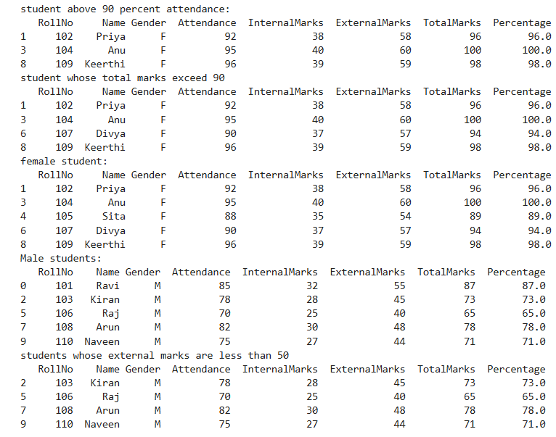

Task E: Ranking and Comparison
. Identify the student with the highest TotalMarks.
. Identify the student with the lowest TotalMarks.
. Display the top three performers based on TotalMarks.
. Display the bottom three performers based on TotalMarks.
. Determine how many students scored above the class average.

Code:
print("student with highest total marks:")
print(df.loc[df["TotalMarks"].idxmax()].to_string())
print("student with lowest total marks:")
print(df.loc[df["TotalMarks"].idxmin()].to_string())
print("top 3 performers:")
print(df.nlargest(3,"TotalMarks").to_string())
print("bottom 3:")
print(df.nsmallest(3,"TotalMarks").to_string())
print("no.of students above class average:")
print(len(df[df['TotalMarks'] > df["TotalMarks"].mean()]))
Output:
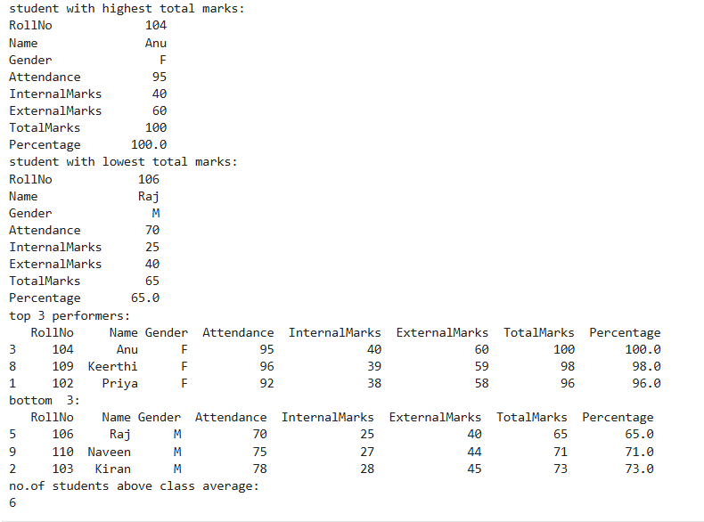

Task F: Group-wise Analysis
. Calculate the average TotalMarks of male students.
. Calculate the average TotalMarks of female students.
. Compare the average attendance of male and female students.
Code:
averagemale = df[df['Gender']=='M']['TotalMarks'].mean()
print(f"average marks for male students: {averagemale}")
print()

averagefemale = df[df['Gender']=='F']['TotalMarks'].mean()
print(f"average marks for female students: {averagefemale}")
print()

compareattmf = df.groupby('Gender')['Attendance'].mean()
print("Average attendance for male and female students:")
print(compareattmf)
Output:
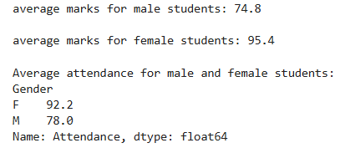

Task G: Data Visualization
. Plot a bar chart showing TotalMarks of all students.
. Plot a histogram of Attendance.
. Plot a pie chart showing the distribution of male and female students.
. Plot a scatter plot between Attendance and TotalMarks.
. Interpret the relationship between Attendance and TotalMarks.
Code:
import matplotlib.pyplot as plt

barcharttotalmarks = df.plot.bar(x='Name', y='TotalMarks', title='Total Marks of Students', legend=False)
plt.show()

histogram = df['Attendance'].plot.hist(title='Attendance Histogram', bins=10)
plt.xlabel('Attendance')

piechartgender = df['Gender'].value_counts().plot.pie(title='Gender Distribution', autopct='%1.1f%%')
plt.ylabel('')

scatterplot = df.plot.scatter(x='InternalMarks', y='ExternalMarks', title='Internal vs External Marks')
plt.show()

Output:
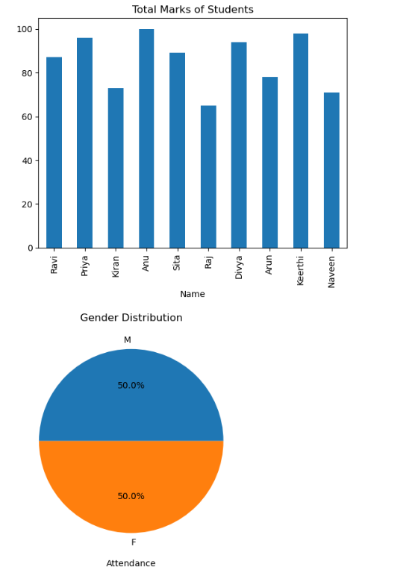
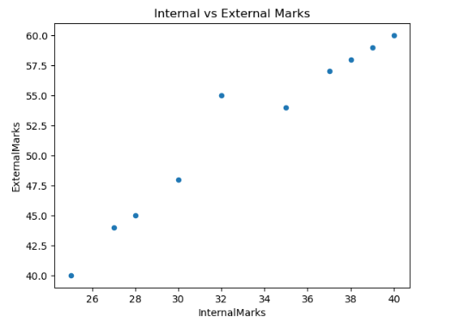

Task H: Observations
. Write any three observations based on the analysis performed.
. State whether higher attendance appears to be associated with better academic
performance.

